aws cloudformation deploy --template-file template-createS3.yaml --stack-name temp-dev-infraestr-dev --parameter-overrides DeploymentBucketName=temp-dev-deploy-files Stage=dev --tags Proyecto=temp-dev-app --no-fail-on-empty-changeset

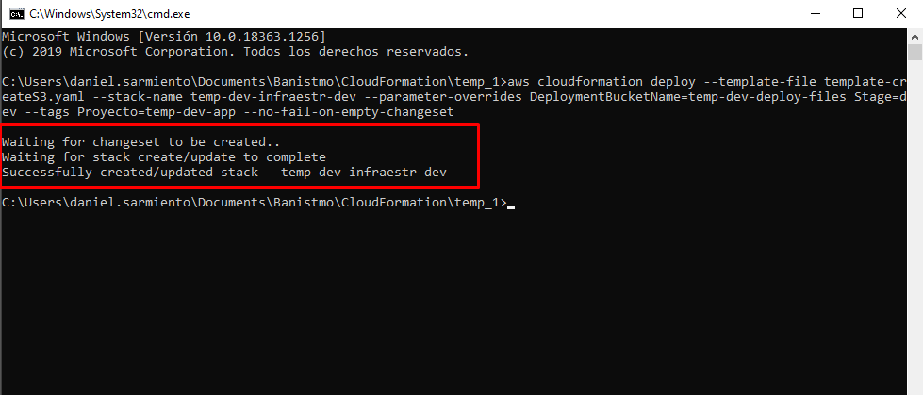

aws cloudformation describe-stack-events --stack-name temp-dev-infraestr-dev

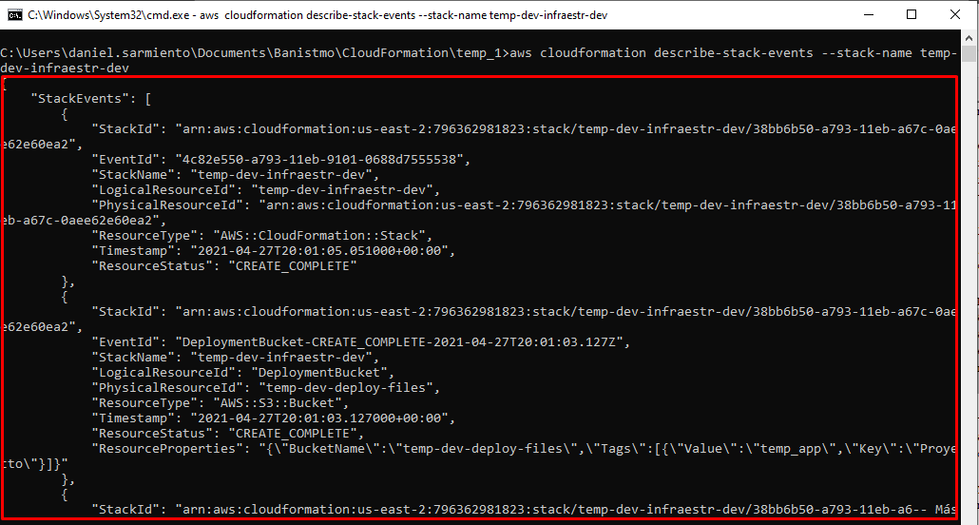

aws s3 cp templateAPIGW.yaml s3://temp-dev-deploy-files/templates/api/task-api-cloudformation-template.yaml

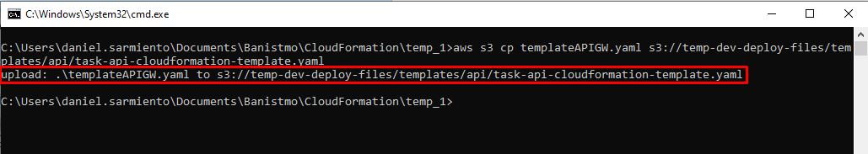

Deploy

aws cloudformation deploy --template-file template-updateS3.yaml --stack-name temp-dev-infraestr-dev --parameter-overrides DeploymentBucketName=temp-dev-deploy-files Stage=dev --tags Proyecto=project-test-app --no-fail-on-empty-changeset